YEAR 11 CHEMISTRY
AECHE
Unit 2

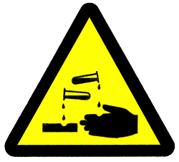

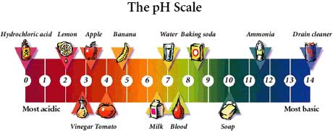

Acids and Bases

Acids and Bases
ACIDS
- Examples of acids.
- Inorganic acids are made from chemicals found in the atmosphere or in rocks:

sulfuric acid H₂SO₄
nitric acid HNO₃
hydrochloric acid HCl
hydrofluoric acid HF
phosphoric acid H₃PO₄
carbonic acid H₂CO₃

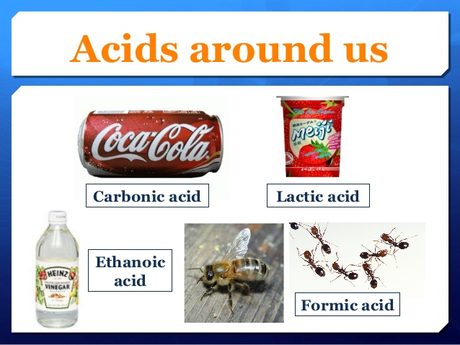
- Organic acid (carboxylic acids) are found in living things. They contain the carboxyl group - COOH:

ethanoic acid CH₃COOH
(acetic acid)
methanoic acid HCOOH
lactic acid CH₃CH(OH)COOH
citric acid HOOCCH₂C(OH)(COOH)CH₂COOH

- Properties of Acids
- Produce 2 ions: hydrogen ions, H⁺, or hydronium ions, H₃O⁺. Produced by the ionisation of an acid in water.

- Acids are proton donors (e.g. gives H⁺ or H₃O⁺ ion.)
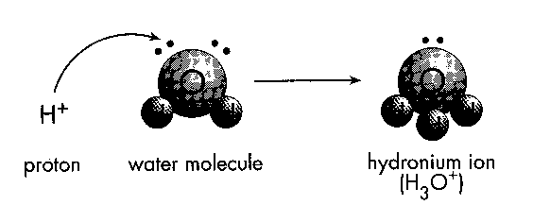
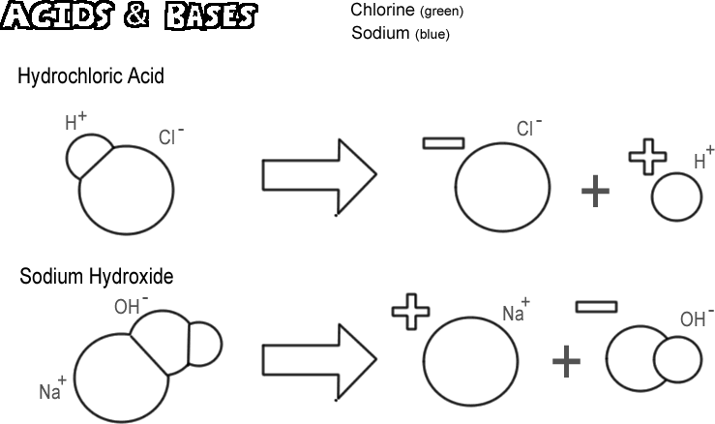

- Turn blue litmus red.
- Yellow, orange, red in universal indicator
- pH below 7.
- Conduct an electric current.
- Taste sour
- Sting or burn the skin
- An acidic solution is one in which the concentration of the hydrogen ions [H⁺] is greater than the concentration of the hydroxide ions [OH⁻].
- A neutral solution is one in which the concentration of the hydrogen ions [H⁺] is equal to the concentration of the hydroxide ions [OH⁻].
- A basic solution is one in which the concentration of the hydrogen ions [H⁺] is less than the concentration of the hydroxide ions [OH⁻].
Acid Neutral Base

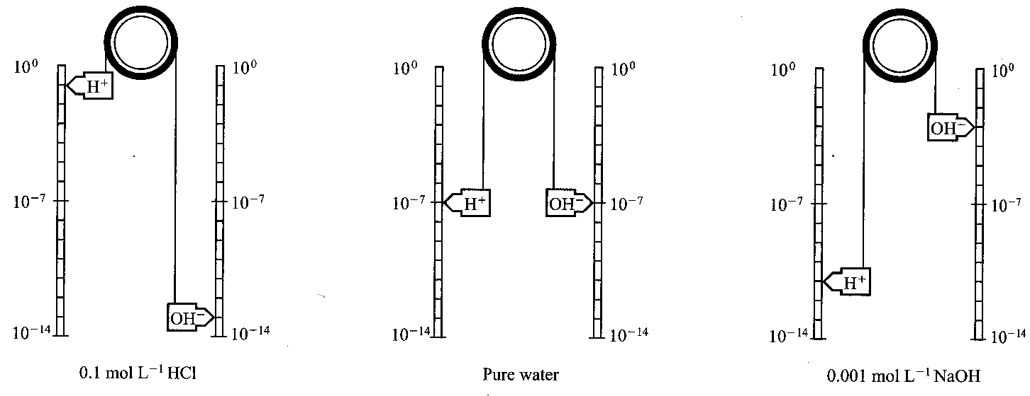

BASES
- Examples of bases.
- Common bases are oxides or hydroxides of metals in Groups I and II of the periodic table.
- NH₃ is a weak base.

- Properties of Metallic Hydroxide Bases

- Relate to the formation of hydroxide ions, OH-.
- A base is a proton acceptor.
- Turn red litmus blue.
- Blue or purple colour in Universal Indicator
- pH greater than 7
- Conduct an electric current.
- Taste bitter.
- React with acids to produce a salt and water.

- Acid-base reactions
Reactions of acids with metal oxides and metal hydroxides

- These reactions are generally referred to as _______________________ reactions.
- The general equations for these two are:
-
-
- Examples of molecular or overall equations are:

HCl_{(aq)} + KOH_{(aq)} → KCl_{(aq)} + H₂O_{(l)}
2HNO_{3(aq)} + Ca(OH)_{2(aq)} → Ca(NO₃)_{2(aq)} + 2H₂O_{(l)}

(We are going to represent the hydronium ion, H₃O⁺_{(aq)}, as H⁺_{(aq)} in this unit)

Write down the ionic equation for these two reactions:
_______________________________________________
_______________________________________________
- The hydroxides of group 13 metals and transition metals are generally sparingly soluble, so the ionic equations include the formula of the solid metal hydroxide.

For example the ionic equation for hydrochloric acid with solid iron(III)hydroxide is:

_______________________________________________________________

(The spectator ion will be _____)

- Reactions between acids and metal oxides generally involve the metal oxide in a solid state.
Give the overall equation and the ionic equation for the next examples:

Nitric acid with magnesium oxide:
Overall: ___________________________________________________________
Ionic: ____________________________________________________
- ARRHENIUS Theory of Acids and Bases

- Acids
- Svante Arrhenius proposed that hydrogen ions were produced by the ionisation of an acid in water. For example in hydrochloric acid the hydrogen chloride molecules are ionised to form hydrogen ions and chloride ions:
      - HCl _{(g)} → H⁺_{(aq)} + Cl⁻_{(aq)}

- Each acid is strong because it is essentially completely ionised in aqueous solution ie. very little HCl molecules in solution.

- Because equilibrium strongly favours formation of products, a single arrow showing only the forward reaction is used in the equation.

- In acids such as ethanoic and citric acid, only a small proportion of the molecules are ionised. These acids are called weak acids:
      - CH₃COOH_{(aq)} ⇋ H⁺_{(aq)} + CH₃COO⁻_{(aq)}

- Double arrows indicate that equilibrium exists between unionised molecules of ethanoic acid and the ions in solution. For example, in a 0.10 mol L⁻¹ ethanoic acid solution only about 1% of ethanoic acid molecules are ionised, equilibrium strongly favours reactants.

- Bases

- Arrhenius also proposed that a base is a substance which produces hydroxide ions in aqueous solution. Sodium Hydroxide (NaOH), an ionic solid, is dissociated in water to form sodium ions and hydroxide ions.

NaOH_{(s)} → Na⁺_{(aq)} + OH⁻_{(aq)}

- Sodium hydroxide and potassium hydroxide are examples of strong bases because they are essentially dissociated into ions in solution.

- Arrhenius theory struggled to explain why ammonia (NH₃) is a base because it is not obvious where the OH⁻ ion comes from.

- As with acids there are numerous bases in which only a small proportion of the base species react with water to form hydroxide ions. These are known as weak bases. Although it contains no hydroxide ions of its own, ammonia produces hydroxide ions by reacting with water:

NH_{3 (aq)} + H₂O _{(l)} ⇋ NH₄⁺ _{(aq)} + OH⁻ _{(aq)}

- Again, equilibrium between unionised NH₃ molecules and NH₄⁺ and OH⁻ ions strongly favours the reactants and only a small proportion of the ions is present.

Summary:

- When dissolved in water, acids form H⁺ ion
HCl _{(g)} → H⁺_{(aq)} + Cl⁻_{(aq)}
SO_{2(g)} + H₂O_{(l)} → H₂SO_{3(aq)} ⇋ H⁺_{(aq)} + HSO₃⁻_{(aq)}
(Arrhenius theory struggled to explain why SO₂ is an acid)

The H⁺ ion is responsible for the solution’s acid properties:
NOTE: the H⁺ will not exist on its own for very long and it links up with a water molecule to form H₃O⁺.
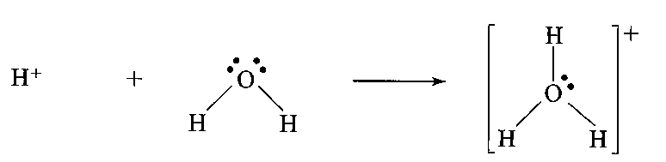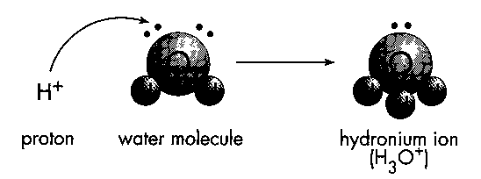
- When dissolved in water, bases form OH⁻ ions.
NaOH_{(s)} → Na⁺_{(aq)} + OH⁻_{(aq)}
Na₂O_{(s)} + H₂O_{(l)} → 2Na⁺_{(aq)} + 2OH⁻_{(aq)}
NH_{3(g)} + H₂O_{(l)} ⇋ NH₄⁺_{(aq)} + OH⁻_{(aq)}
(Arrhenius theory struggled to explain why Na₂O and NH₃ are bases)

The OH⁻ ion is responsible for the solution’s basic properties:
- When acids are added to bases in the correct stoichiometric ration, neutralisation occurs
H⁺ _{(aq)} + OH⁻ _{(aq)} → H₂O _{(l)}

NC p323 QS 7.3
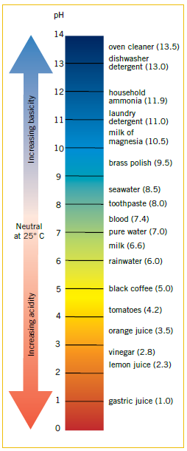
- Indicators and pH

- The pH scale
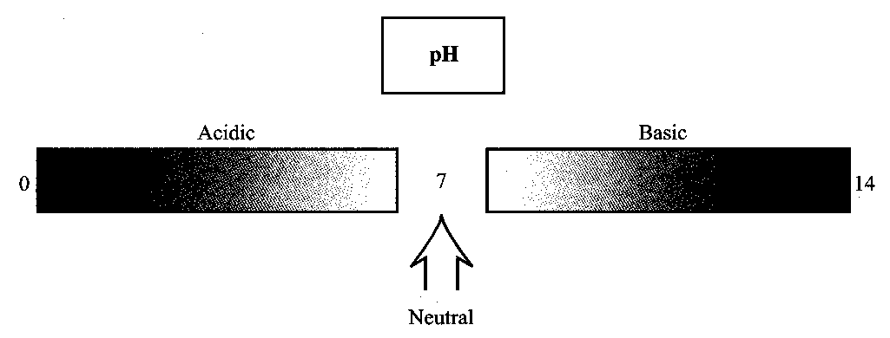

The pH of an aqueous solution is defined by:
pH = -log₁₀[H⁺]
- pH of water or a neutral solution is 7.0
- pH values less than 7.0 are acids.
- pH values greater than 7.0 are bases.

• Water has a covalent molecular structure with molecules of formula H₂O. In any sample of water, some molecules exist as H⁺ _{(aq)} and OH⁻ _{(aq)}.

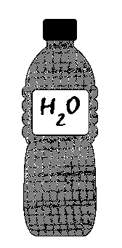
In pure water at 298 K, the concentration of H⁺ _{(aq)} and OH⁻ _{(aq)} is equal:

[H⁺] = [OH⁻] = 1.0 x 10⁻⁷ mol L⁻¹

where [H⁺] is the concentration of H⁺ _{(aq)} in mol L⁻¹.
[OH⁻] is the concentration of OH⁻ _{(aq)} in mol L^{-1.}

• These ions are produced by an equilibrium reaction known as ionisation:

H₂O _{(l)} ⇋ H⁺ _{(aq)} + OH⁻ _{(aq)}
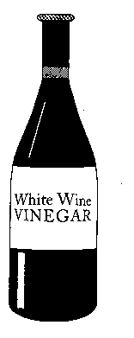
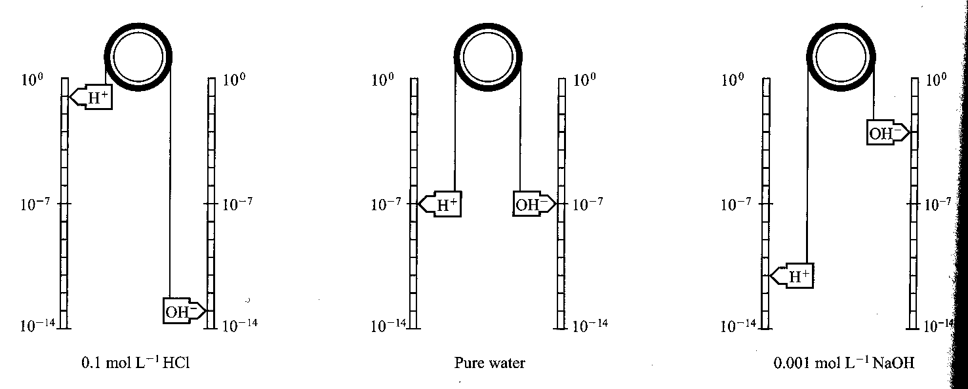

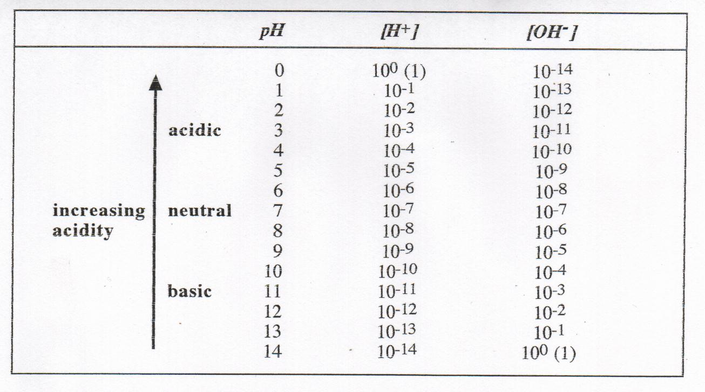
In an acidic solution, there are more H⁺ ions.
[H⁺] > [OH⁻]
[H⁺] > 1.0 x 10⁻⁷ mol L⁻¹
[OH⁻] < 1.0 x 10⁻⁷ mol L⁻¹
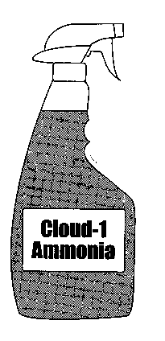

In a basic solution, there are more OH⁻ ions.
[OH⁻] > [H⁺]
[OH⁻] > 1.0 x 10⁻⁷ mol L⁻¹
[H⁺] < 1.0 x 10⁻⁷ mol L⁻¹

PROBLEM SET 1 Answers p24

1. In the following pairs of solutions
a. 0.1 mol L⁻¹ HCl and 0.1 mol L⁻¹ CH₃COOH
- 0.1 mol L⁻¹ NaOH and 0.1 mol L⁻¹ NH₃
predict which solution would exhibit

i. The highest [H⁺] a. b.
ii. The highest pH a. b.
iii. The greatest electrical conductivity a. b.
2. Give an example of each of the following:
a. a concentrated solution of a strong acid.
b. a dilute solution of a strong base.
c. a concentrated solution of a weak acid.
3. Write equations for the ionisation or dissociation of the following:
a. The strong acid HBr.
b. The weak acid H₂SO₃.

- Measuring pH
- using indicators
- A pH indicator is a chemical compound added in small amounts to a solution so the pH of the solution can be determined visually. Hence, a pH indicator is a chemical detector for hydronium ions or hydrogen ions.
- There are many different natural and synthetic indicators.
e.g. Synthetic indicators:
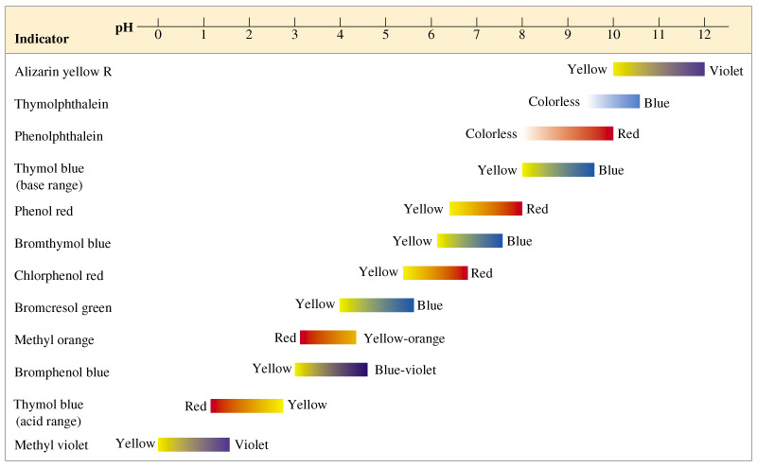

e.g. Natural indicators:


- Universal indicator: produces colour changes depending on the pH of the solution.

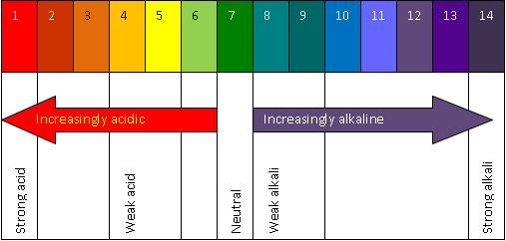

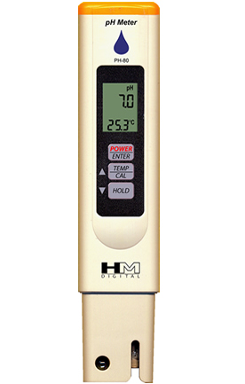
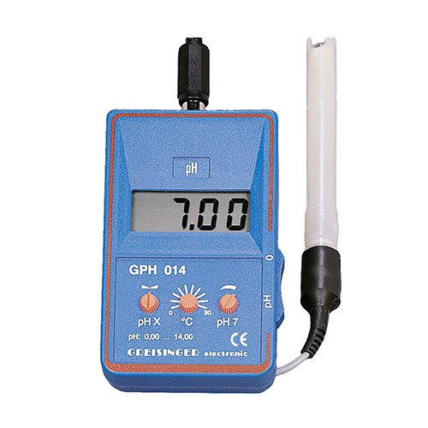
- using a pH meter

NC p328 Worked example 7.5
Complete a-d
NC p329 QS 7.4
EC p153-5 Set 30

Reactions of acids and bases

- Reactions of acids with metal oxides and hydroxides

- These reactions are generally referred to as reactions.
- The general equations for these two are:
-

-
- Examples of molecular or overall equations are:

HCl_{(aq)} + KOH_{(aq)} → KCl_{(aq)} + H₂O_{(l)}
2HNO_{3(aq)} + Ca(OH)_{2(aq)} → Ca(NO₃)_{2(aq)} + 2H₂O_{(l)}
(We are going to represent the hydronium ion, H₃O⁺_{(aq)}, as H⁺_{(aq)} in this unit)

Write down the ionic equation for these two reactions:

- The hydroxides of group 13 metals and transition metals are generally sparingly soluble, so the ionic equations include the formula of the solid metal hydroxide.

For example the ionic equation for hydrochloric acid with solid iron(III)hydroxide is:

(The spectator ion will be )

- Reactions between acids and metal oxides generally involve the metal oxide in a solid state.
Give the overall equation and the ionic equation for the next examples:

Nitric acid with solid magnesium oxide:
Overall:

Ionic:

Sulfuric acid with solid sodium oxide:
Overall:

Ionic:

- Reactions of acids with carbonates and hydrogen carbonates

- The general equations for these two are:
-

- Group 1 metal carbonates and all hydrogen carbonates are soluble in water and carbonates of all the other metals are insoluble in water so their formulae are written as solids. Write the ionic equation of the following:
Reaction of hydrochloric acid with aluminium carbonate

Reaction of nitric acid with solid potassium hydrogencarbonate

- Many antacids have metal hydroxides, carbonates and hydrogen carbonates as the active ingredient.

- Reactions of acids with reactive metals (K, Na, Ca, Mg, Zn, Al and Fe)

- The general equation for this reaction is:

acid + reactive metal →

- Examples are: (complete the molecular and ionic equation)
Hydrochloric acid with magnesium
ME:
IE:

- Reactions of acids with sulphides (S⁻²) and sulphites (SO₃⁻²)

- The general equations for these two are:
  - acid + sulfide → salt solution + hydrogen sulphide gas
  - acid + sulfite → salt solution + sulfur dioxide gas + water

- Examples are: (complete the molecular and ionic equation)
Nitric acid with a solution of sodium sulphide
ME:
IE:
Hydrochloric acid with solid magnesium sulfite
ME:
IE:
- If a weak acid is involved, it will be represented in the ionic equation in their “un-ionised” form eg. acetic acid will be CH₃COOH_{(aq).}

Problem Set 2 Answers p24
1. Write ionic equations for the reactions between the following:
• zinc and hydrochloric acid

• solid calcium carbonate and hydrochloric acid

• solid potassium oxide and sulfuric acid

• barium hydroxide solution and nitric acid

Summary
Reactions of acids – complete the following ionic equations.

- React with metal hydroxides (base) to produce a salt plus water.
acid + metal hydroxide → salt + water
nitric acid + potassium hydroxide solution

- React with metal oxides (base) to produce a salt and water.
acid + metal oxide → salt + water
hydrochloric acid + solid sodium oxide

- React with carbonates and hydrogen carbonates to form carbon dioxide gas.

acid + carbonate → carbon dioxide + water + salt
nitric acid + sodium carbonate solution

acid + hydrogencarbonate → carbon dioxide + water + salt
sulfuric acid + potassium hydrogen carbonate solution

- React with reactive metals such as K, Na, Ca, Mg, Zn, Al and Fe to produce hydrogen gas.

acid + reactive metal → hydrogen + salt
hydrochloric acid + zinc metal

• Reacts with ammonia (NH₃) solution to form ammonium ions (NH₄⁺).
acid + ammonia solution → ammonium ions
hydrochloric acid + ammonia solution

Reactions of bases – complete the following ionic equations.

- Basic solutions react with non-metal oxides (acidic oxides) producing a salt solution and water.
OH⁻ + non-metal oxide → salt + water
The non-metal oxide will accept an oxygen atom from the base during the reaction.
sodium hydroxide solution + sulfur dioxide gas

potassium hydroxide solution + carbon dioxide gas

- Basic solutions react with ammonium salts (acidic) producing a salt solution, water and ammonia gas.
OH⁻ + ammonium salt → salt + water + ammonia gas
Potassium hydroxide solution + ammonium chloride solution

- Bases are divided into two groups:
i. Strong Bases: sodium hydroxide and potassium hydroxide - they completely dissociate into ions in solutions.

NaOH _{(s)} → Na⁺ _{(aq)} + OH⁻ _{(aq)}

ii. Weak bases: small proportion of hydroxide ions formed.

NH_{3 (aq)} + H₂O _{(l)} ⇋ NH₄⁺ _{(aq)} + OH⁻ _{(aq)}

Problem Set 3 Answers p24
- Write equations for the following. All working should be done on scrap paper so that only the ionic equation is shown.
ACID + BASE
  - Dilute nitric acid added to a solution of potassium hydroxide

  - Dilute sulphuric acid added to a solution of barium hydroxide

  - Dilute hydrochloric acid added to a solution of sodium hydroxide

ACID + CARBONATE
  - Phosphoric acid added to solid silver carbonate

  - Sulphuric acid added to potassium carbonate solution

  - Mixing of nitric acid and sodium carbonate solutions

ACID + METAL
  - Adding hydrochloric acid to solid zinc

  - Adding sulphuric acid to solid lead

ACID +HYDROGEN CARBONATE
  - Mixing of nitric acid and sodium hydrogen carbonate solutions

  - The dissolving of sodium hydroxide (solid)

PROBLEM SET 4 Answers p25

1. Predict the reaction products (no equation needed) formed when the following pairs of reagents are combined. Write molecular formula for the products formed and indicate their phase (i.e. _{(s), (l), (g)} or _{(aq)}). The first has been done to show you.

a. sulphuric acid and magnesium carbonate MgSO_{4 (aq)} + CO_{2 (g)} + H₂O _{(l)}
b. hydrochloric acid and calcium metal
c. nitric acid and sodium sulphite
d. acetic acid and magnesium hydroxide
e. sulphuric acid and calcium oxide
f. ammonium chloride and sodium hydroxide
g. carbon dioxide and sodium hydroxide

2. Complete the following to show balanced molecular equations for the chemical reaction that takes place when each of the following reagents is combined.

a. HNO₃ _{(aq)} and Al₂(CO₃)₃ _{(s)} →
b. HCl _{(aq)} and Fe(OH)₃ _{(s)} →
c. HNO₃ _{(aq)} and BaO _{(s)} →
d. NH₄Cl _{(aq)} and KOH _{(aq)} →
e. HCl _{(aq)} and Fe _{(s)} →
f. ethanoic acid and solid zinc carbonate

g. carbon dioxide gas and powdered barium hydroxide

h. phosphoric acid and solid barium hydroxide

Up until now you may have written all ionic equations involving solid ionic substances as if they were in solution. From now on, you must show the solid as a solid in the ionic equation so that the full observations can be given. The first question below has been done for you to illustrate this.

3. A chemical change will happen in some of the following situations. If a reaction is expected write a balanced net ionic equation for the reaction and give an observation that could be expected for this reaction. Where no reaction occurs write N.R.

a. Powdered copper II carbonate is added to a nitric acid solution.
A green-blue solid reacts in a colourless solution.
The solution turns blue and a colourless, odourless gas is evolved.
CuCO_{3 (s)} + H⁺ _{(aq)} → Cu²⁺_{(aq)} + CO_{2 (g)} + H₂O _{(l)}
b. A sodium sulphite solution is added to hydrochloric acid.

c. Sulphur dioxide gas is bubble through a potassium hydroxide solution.

d. Granulated zinc is added to hydrochloric acid solution.

e. A sulfuric acid solution is added to solid copper II hydroxide.

f. Magnesium ribbon is added to an ethanoic acid solution.

g. A sulfuric acid solution is added to solid barium carbonate.

4. Two students carried out several chemical tests on the following substances:
CuO _{(s)} Ca(OH)₂ _{(s)} CO₂ (g) MgCO₃ _{(s)}
They treated these substances with different reagents as outlined below. Using their observations, determine which of the above substances is being tested in each case. You can only use each once.
Test #1: A nitric acid solution was added to one of the above substance. The substance was observed to dissolve and produce a clear blue solution.

Test #2: A solution of sodium hydroxide was added to a sample of this substance, however no reaction was observed. Another sample of the substance was dissolved in hydrochloric acid, producing a clear colourless solution. No gas was evolved.

Test #3: This substance was found to dissolve in a potassium hydroxide solution producing a
colourless clear solution. The resulting solution was added to a hydrochloric acid and colourless gas was evolved.

Test #4: Addition of sulfuric acid to this substances resulted in the formation of a colourless gas.

EC p149-51 Set 29
Calculations involving acids and bases

Example:
Consider the neutralisation reaction between sodium hydroxide and sulphuric acid.
2NaOH + H₂SO₄ Na₂SO₄ + 2H₂O
- How many moles of sodium hydroxide would be needed to neutralise 250mL of a 0.8 molL⁻¹ solution of H₂SO₄?

- What mass of sodium hydroxide would this be?

- What is the pH of this sulphuric acid solution before neutralisation?

NC Worked example 7.5 p329 a-d
NC QS 7.4 p329
EC p157-60 Set 31 and Set 32

STRENGTHS OF ACIDS AND BASES
• An ionisation or hydrolysis equation shows how an acid or base produces OH⁻ _{(aq)} and H⁺ _{(aq)} in water. A single arrow (→) denotes a strong base or acid (complete ionisation or dissociation) and a double arrow (⇋ ) denotes a weak acid or base (partial ionisation or dissociation).

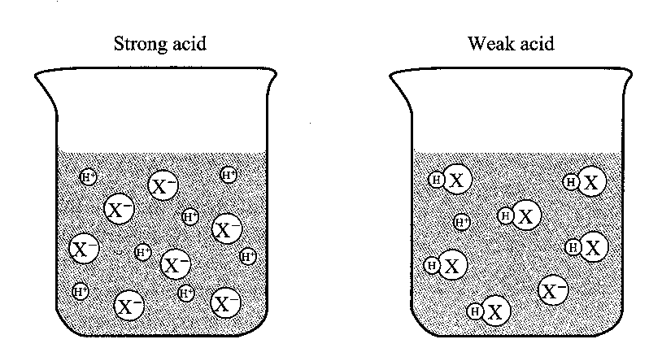
Strong Acids

• Completely ionise to produce hydrogen ions in aqueous solutions.
HCl _{(g)} → H⁺ _{(aq)} + Cl⁻ _{(aq)}

or

HCl _{(g)} + H₂O _{(l)} → H₃O⁺ _{(aq)} + Cl⁻ _{(aq)}

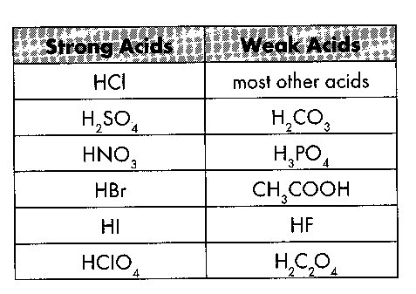
• Strong proton donors.

Weak Acids

• Only partially ionised in water.
CH₃COOH _{(aq)} ⇋ H⁺ _{(aq)} + CH₃COO⁻ _{(aq)}
or
CH₃COOH _{(aq)} + H₂O _{(l)} ⇋ H₃O⁺ _{(aq)} + CH₃COO⁻ _{(aq)}
• Equilibrium established between ethanoic acid molecules and hydrogen ions and ethanoate ions; reverse reaction favoured.
Strong Bases

• All bases and alkalis from oxides and hydroxides are strong bases. Soluble bases are called alkalis.

• Strong bases - completely dissociate to produce hydroxide ions in aqueous solutions.
NaOH_{(s)} → Na⁺_{(aq)} + OH⁻_{(aq)}
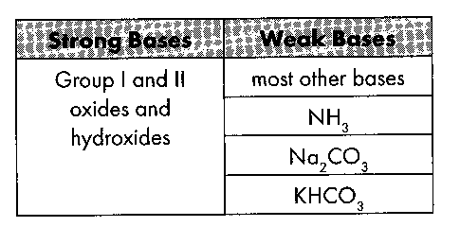
• Groups of the periodic table which produce strong bases are group I and II metal hydroxides.
• Group II metal hydroxides:
i. produce 2 moles of hydroxide ions.
ii. limited solubility.
Weak Bases

• Small proportion of molecules or ions react with water to form hydroxide ions:
NH₃ _{(aq)} + H₂O _{(l)} ⇋ NH₄⁺ _{(aq)} + OH⁻ _{(aq)}
• Anions which are weak bases include carbonates, ethanoate, fluoride and phosphate.
• Neutral substances do not affect the concentration of OH⁻ _{(aq)} or H⁺ _{(aq)} ions when dissolved in water. Common examples of neutral ions include Li⁺, Na⁺, K⁺, Mg^{2+,} Ca²⁺, Ba²⁺, Cl⁻, Br⁻, I⁻, NO₃⁻

Ionisation of Common Acids Listed in Order of Decreasing Strength
Acid Strength | Acid Name | Ionisation Equation | Major Species Present in Solution
strong | HCl hydrochloric acid | HCl _{(aq)} →  H⁺ _{(aq)} + Cl⁻ _{(aq)} | almost entirely H⁺ _{(aq)} and Cl⁻ _{(aq)} negligible HCl _{(aq)}.
 | H₂SO₄ sulphuric acid | H₂SO₄ _{(aq)} → H⁺ _{(aq)} + HSO₄⁻ _{(aq)} | almost entirely H⁺ _{(aq)} and HSO₄⁻ _{(aq)}, some SO₄⁻² _{(aq)}, negligible H₂SO₄ _{(aq)}.
 | HNO₃ nitric acid | HNO₃ _{(aq)} →  H⁺ _{(aq)} + NO₃⁻ _{(aq)} | almost entirely H⁺ _{(aq)} and NO₃⁻ _{(aq)}, negligible HNO₃ _{(aq)}.
 | H₂C₂O₄ oxalic acid | H₂C₂O₄ _{(aq)}   H⁺ _{(aq)} + HC₂O₄⁻ _{(aq)} | mostly H₂C₂O₄ _{(aq)}, moderate concentrations of H⁺ _{(aq)} and HC₂O₄⁻ _{(aq)}.
 | H₂SO₃ sulphurous acid | H₂SO₃ _{(aq)}   H⁺ _{(aq)} + HSO₃⁻ _{(aq)} | mostly H₂SO₃ _{(aq)}, moderate concentrations of H⁺ _{(aq)} and HSO₃⁻ _{(aq)}.
moderate | HSO₄⁻ hydrogensulfate | HSO₄⁻ _{(aq)} H⁺ _{(aq)} + SO₄⁻² _{(aq)} | mostly HSO₄⁻ _{(aq)}, moderate concentrations of H⁺ _{(aq)} and SO₄⁻² _{(aq)}.
 | H₃PO₄ phosphoric acid | H₃PO₄ _{(aq)}  H⁺ _{(aq)} + H₂PO₄⁻ _{(aq)} | mostly H₃PO₄ _{(aq)}, low H⁺ _{(aq)} and H₂PO₄⁻ _{(aq)}, very low HPO₄²⁻ _{(aq)}.
 | CH₃COOH ethanoic acid | CH₃COOH _{(aq)} H⁺ _{(aq)} + CH₃COO⁻ _{(aq)} | almost entirely CH₃COOH _{(aq)}, low H⁺ _{(aq)} and CH₃COO⁻ _{(aq)}.
 | H₂PO₄⁻ dihydrogen- phosphate ion | H₂PO₄⁻ _{(aq)}  H⁺ _{(aq)} + HPO₄⁻² _{(aq)} | almost entirely H₂PO₄⁻ _{(aq)}, low concentrations of H⁺ _{(aq)} and HPO₄⁻² _{(aq)}.
 | H₂S hydrogen sulfide | H₂S _{(aq)}   H⁺ _{(aq)} + HS⁻ _{(aq)} | almost entirely H₂S _{(aq)}, very low concentrations of H⁺ _{(aq)} and HS⁻ _{(aq)}.
weak | NH₄⁺ ammonium ion | NH₄⁺ _{(aq)}   H⁺ _{(aq)} + NH₃ _{(aq)} | almost entirely NH₄⁺ _{(aq)}, very low concentrations of H⁺ _{(aq)} and NH₃ _{(aq)}.

POLYPROTIC ACIDS AND BASES

Monoprotic acids - one hydrogen atom per molecule. Examples include: HCl, HNO₃ and CH₃COOH.
HCl _{(g)} + H₂O _{(l)} → H₃O⁺ _{(aq)} + Cl⁻ _{(aq)}

Note: Ethanoic acidCH₃COOH has 4 hydrogen atoms, but only 1 is the acidic hydrogen (monoprotic).
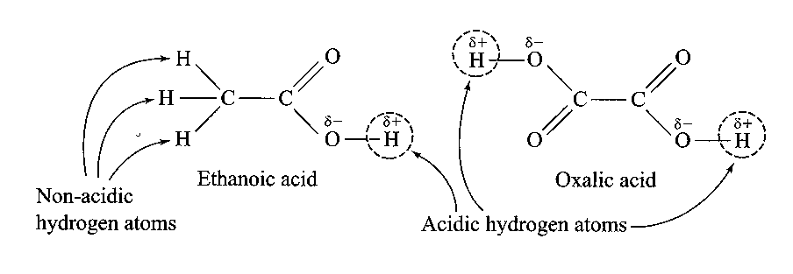

Diprotic acids - two ionisable hydrogen atoms.
H₂SO₄ _{(l)} + H₂O _{(l)} → H₃O⁺ _{(aq)} + HSO₄⁻ _{(aq)}
HSO₄⁻ _{(aq)} + H₂O _{(aq)} ⇋ H₃O⁺ _{(aq)} + SO₄²⁻ _{(aq)}

Oxalic acid H₂C₂O₄ has 2 hydrogen atoms and they are both acidic hydrogen (diprotic).

Triprotic acids - three ionisable hydrogen atoms.
H₃PO₄ _{(aq)} + H₂O _{(l)} ⇋ H₃O⁺ _{(aq)} + H₂PO₄⁻ _{(aq)}
H₂PO₄⁻ _{(aq)} + H₂O _{(l)} ⇋ H₃O⁺ _{(aq)} + HPO₄²⁻ _{(aq)}
HPO₄²⁻ _{(aq)} + H₂O _{(l)} ⇋ H₃O⁺ _{(aq)} + PO₄³⁻ _{(aq)}
Some bases produce more than one hydroxide ion when they dissociate in water Mg(OH)₂ and Ca(OH)₂.
Concentrated/dilute - relative amounts of solute in a solvent,
Strong/weak - relative proportion of ions to molecules in a solvent.

e.g. 0.5 mol L⁻¹ CH₃COOH dilute solution of a weak acid.
5 mol L⁻¹ CH₃COOH concentrated solution of a weak acid.
0.1 mol L⁻¹ HCl dilute solution of a strong acid.
10 mol L⁻¹ HCl concentrated solution of a strong acid.

PROBLEM SET 5 Answers p26
1. How many moles of hydroxide ions would react with one mole of the following acids?
a. HNO₃ b. H₂SO₄ c. H₃PO₄
d. HF e. CH₃COOH f. HCOOH
2. How many moles of hydrogen ions would react with one mole of the following bases?
a NaOH b Fe(OH)₃ c Ca(OH)₂

SUMMARY Acids and Bases Summary. Answers p27
Acids:
- Acids are inorganic e.g. etc. or organic (contain COOH) e.g.
- Properties -
• Produce 2 ions: ions, H⁺, or hydronium ions, produced by the ionisation of acid in water.
• Acids are donors (e.g. gives H⁺ or H₃O⁺ ion.)
• Turn blue litmus Conduct an current; Taste
- Neutralization reaction with OH⁻_{(aq)} to produce water.
e.g. barium hydroxide solution plus nitric acid produces
ionic equation:
- React with reactive metals such as K, Na, Ca, Mg, Zn, Al and Fe to produce hydrogen gas.
e.g. Calcium metal plus sulfuric acid produces
ionic equation:
• React with carbonates and hydrogen carbonates to form carbon dioxide gas.
Solid barium carbonate plus hydrochloric acid produces
ionic equation:
• React with metal oxides to produce a salt and water.
Solid II copper oxide plus hydrochloric acid produces
ionic equation:
• React with metal hydroxides to produce a salt plus water.
Solid magnesium hydroxide plus nitric acid produces
ionic equation:
• Reacts with sulfites (SO₃²⁻) to produce sulfur dioxide gas and water
Solid sodium sulfite plus conc. sulfuric acid produce
ionic equation:
• Reacts with sulfides (S²⁻) to produce hydrogen sulfide gas.
Solid Iron II sulfide plus nitric acid produce
ionic equation:
• Reacts with ammonia (NH₃) solution to form ammonium ions (NH₄⁺).
Ammonia solution plus hydrochloric acid produce
ionic equation:
• Acids divided into two groups:
(a) Strong Acid - completely ionised in water, HCl, H₂SO₄
ionic equation for sulfuric acid:
(b) Weak Acid - small proportion of molecules ionised, CH₃COOH, C₆H₈O₇ (citric acid).
ionic equation for ethanoic acid:

Bases: Common bases are oxides or hydroxides of metals in Groups I and II of the periodic table.
  - Properties of Metallic Hydroxide Bases
• Relate to the formation of , OH⁻.
• A base is a proton
• Turn red litmus Conduct an electric current. Taste
• React with acids to produce a and
sodium hydroxide plus sulfuric acid produces
ionic equation:
• Basic solutions react with non-metal oxides (acidic oxides) producing a salt solution and water.
• Basic solutions reacts with ammonium salts (acidic) producing a salt solution, water and ammonia gas.
Ammonium chloride plus sodium hydroxide produces

ionic equation:
• Bases are divided into two groups:
(a) Strong Bases: sodium hydroxide and potassium hydroxide - completely dissociate into ions in solutions.
(b) Weak bases: ammonia solution - small proportion of hydroxide ions formed

Arrhenius Theory
- Acids compounds which in aqueous solution produce H⁺_{(aq)}
- Bases compounds which produce OH⁻_{(aq)}
- Alkalis (soluble bases) and bases generally oxides, hydroxides or carbonates of metals. NH_{3 (aq)} also base.
- Arrhenius theory unable to account for why metal carbonates or NH_{3 (aq)} are basic.
Complete the following equations from an Arrhenius point of view:
hydrogen chloride gas dissolved in water
ethanoic acid dissolved in water
3. sodium hydroxide solid dissolved in water
4. ammonia gas dissolved in water

The pH Acidity Scale
- The pH of an aqueous solution is defined by: pH = -log₁₀[H⁺]
pH of water or a neutral solution is pH
pH values less than 7.0 are
pH values greater than 7.0 are
• Water has a covalent molecular structure with molecules of formula H₂O. In any sample of water, some molecules exist as H⁺_{(aq)} and OH⁻ _{(aq)}. In pure water at 298 K, concentration of H⁺ _{(aq)} and OH⁻ _{(aq)} is equal:
[H⁺] = [OH⁻] = 1 x 10⁻⁷ mol L⁻¹
Where [H⁺] is the concentration of H⁺ _{(aq)} in mol L⁻¹. [OH⁻] is the concentration of OH⁻ _{(aq)} in mol L^{-1.}
• These ions are produced by an equilibrium reaction known as ionisation: H₂O _{(l)} ⇋ H⁺ _{(aq)} + OH⁻ _{(aq)}

Strengths Of Acids And Bases
ACIDS:
- Arrhenius: Acid strength measured by degree of dissociation, strong acids complete dissociation, Arrhenius: HCl _{(g)} →
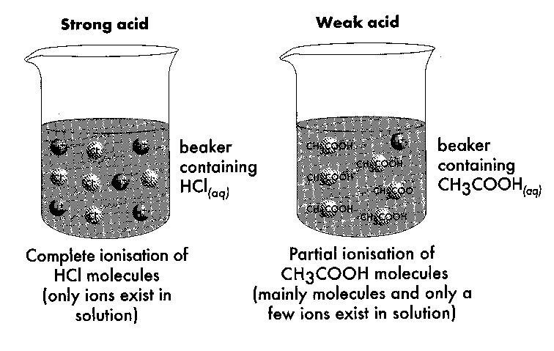
- weak acids slightly dissociated, Arrhenius: CHC₃OOH (aq) ⇋
- weak acids hold protons more strongly: B-L: CH₃COOH _{(aq)} + H₂O _{(l)} ⇋
BASES:
- Arrhenius: strong bases are completely dissociated e.g. NaOH_{(s)} → Na⁺_{(aq)} + OH⁻_{(aq)}
- Arrhenius: weak bases only small proportion of molecules or ions react to form hydroxide ions.
NH₃ _{(aq)} + H₂O _{(l)} ⇋ NH₄⁺ _{(aq)} + OH⁻ _{(aq)}
- An ionisation or hydrolysis equation shows how an acid or base produces OH⁻ _{(aq)} and H⁺ _{(aq)} in water. A single arrow (→) denotes a strong base or acid (complete ionisation) and a double arrow (⇋ ) denotes a weak acid or base (partial ionisation).

Polyprotic Acids And Bases: more than one proton which can dissociate.
Monoprotic acids - one hydrogen atom per molecule. Examples include: HCl, HNO₃ and CH₃COOH.
HCl _{(g)} + H₂O _{(l)} → H₃O⁺ _{(aq)} + Cl⁻ _{(aq)} HCl is a strong acid hence the products are favoured
Diprotic acids - two ionisable hydrogen atoms.
H₂SO₄ _{(l)} + H₂O _{(l)} → H₃O⁺ _{(aq)} + HSO₄⁻ _{(aq)} H₂SO₄ strong acid than H₃O⁺ so products favoured
HSO₄⁻ _{(aq)} + H₂O _{(aq)} ⇋ H₃O⁺ _{(aq)} + SO₄²⁻ _{(aq)} H₃O⁺ stronger acid than HSO₄⁻ so reactants favoured
Triprotic acids - three ionisable hydrogen atoms.
NOTE: H₃PO₄ is a weak acid so ionisation occurs to only a small extent and to a lesser degree each time. Reactants generally favoured as H₃O⁺ is a stronger acid.

H₃PO₄ _{(aq)} + H₂O _{(l)} ⇋ H₃O⁺ _{(aq)} + H₂PO₄⁻ _{(aq)}
H₂PO₄⁻ _{(aq)} + H₂O _{(l)} ⇋ H₃O⁺ _{(aq)} + HPO₄²⁻ _{(aq)}
HPO₄²⁻ _{(aq)} + H₂O _{(l)} ⇋ H₃O⁺ _{(aq)} + PO₄³⁻ _{(aq)}
Concentration Vs Dilute: (refer also to molarity)
e.g. 0.5 mol L⁻¹ CH₃COOH dilute solution of a weak acid.
5 mol L⁻¹ CH₃COOH concentrated solution of a weak acid.
0.1 mol L⁻¹ HCl dilute solution of a strong acid.
10 mol L⁻¹ HCl concentrated solution of a strong acid.
Using different acids give examples of:
  - dilute solution of a strong acid

  - concentrated solution of a strong acid

  - concentrated solution of a weak acid

  - dilute solution of a weak acid

Acid-Base Neutralisation Reactions
• Neutralisation reaction - the acidic and basic properties of reactants are nullified.
• Products produced when a strong acid reacts with a strong base is water plus a salt:
Example:
Ionic equation:
• When a weak acid reacts with a strong base – products are water plus a salt:
Example:
Ionic equation:
Review of Common Reactions which you must learn:
ACIDS: (Strong e.g. HCl; weak e.g. CH₃COOH, H₃PO₄; non-metal oxides acidic)
acid + reactive metal → hydrogen + salt
acid + carbonate or hydrogen carbonate → carbon dioxide + water + salt
acid + metal oxide or hydroxide → salt + water
acid + ammonia solution → ammonium ions
(strong acid) + sulfite → salt + sulfur dioxide + water
(strong acid) + sulfide → salt + hydrogen sulfide
(strong acid) + many metals → salt + water + other gases
e.g. Cu + 2H₂SO₄ → Cu²⁺ + SO₂ + SO₄²⁻ + 2H₂O

Strong Acids:
Completely ionise: HCl _{(g)} → H⁺ _{(aq)} + Cl⁻ _{(aq)} or HCl _{(g)} + H₂O _{(l)} → H₃O⁺ _{(aq)} + Cl⁻ _{(aq)}

Weak Acids:
Only partially ionise in water.
CH₃COOH _{(aq)} ⇋ H⁺ _{(aq)} + CH₃COO⁻ _{(aq)} or CH₃COOH _{(aq)} + H₂O _{(l)} ⇋ H₃O⁺ _{(aq)} + CH₃COO⁻ _{(aq)}
Equilibrium established between ethanoic acid molecules and hydrogen ions and ethanoate ions; reverse reaction favoured.

BASES (Strong have OH⁻ ion; weak NH₃, Na₂CO₃ ; metal oxides basic)
base + acid → salt + water
hydroxides + non-metal oxides → salt + water e.g. Hydroxides + carbon dioxide gas → carbonate salt + water
hydroxides + ammonium salts (acidic) → salt + water + ammonium gas (NH₃ is a weak base)

Strong Bases
All bases and alkalis, except ammonia, are oxides, hydroxides or carbonates of metals. Soluble bases - alkalis.
Strong bases completely dissociate NaOH_{(s)} → Na⁺_{(aq)} + OH⁻_{(aq)}
Groups of the periodic table which produce strong bases are group I and II metal hydroxides.

Weak Bases
Small proportion of molecules or ions react with water to form OH⁻ ions :
NH₃ _{(aq)} + H₂O _{(l)} ⇋ NH₄⁺ _{(aq)} + OH⁻ _{(aq)}
Anions which are weak bases include carbonates, ethanoate, fluoride and phosphate.

PROBLEM SET 1

1.
i. a. HCl b. NH₃
ii. a. CH₃COOH b. NaOH
iii. a. HCl b. NaOH
2.
a. 18 M H₂SO₄
b. 0.1 M NaOH
c. 6 M CH₃COOH
3.
a. HBr _{(aq)} → H⁺_{(aq)} + Br⁻_{(aq)}
b. H₂SO_{3 (aq)} ⇋ H⁺_{(aq)} + HSO₃⁻_{(aq)}

Problem Set 2
• zinc and hydrochloric acid 2H⁺_{(aq)} + Zn_{(s)} H_{2(g)} + Zn²⁺_{(aq)}
• solid calcium carbonate and hydrochloric acid2H⁺_{(aq)} + CaCO_{3(s)} CO_{2(g)} + Ca²⁺_{(aq)} + H₂O_{(l)}
• solid potassium oxide and sulfuric acid 2H⁺(aq) + K₂O(s) 2K⁺(aq) + H₂O(l)
• barium hydroxide solution and nitric acid H⁺(aq) + OH⁻(aq) H₂O(l)

Problem Set 3
- H⁺_{(aq)} + OH⁻_{(aq)} → H₂O _{(l)}
- H⁺_{(aq)} + SO₄²⁻_{(aq)} + Ba²⁺_{(aq)} + OH⁻_{(aq)} → BaSO_{4(s)} H₂O _{(l)}
- H⁺_{(aq)} + OH⁻_{(aq)} → H₂O _{(l)}
- 2H₃PO_{4(aq)} + 3Ag₂CO_{3(s)} → 2Ag₃PO_{4(s)} + 3CO_{2 (g)} + 3H₂O _{(l)}
- 2H⁺_{(aq)} + CO₃⁻²_{(aq)} → CO_{2 (g)} + H₂O _{(l)}
- 2H⁺ + CO₃²⁻_{(aq)} → CO_{2 (g)} + H₂O _{(l)}
- 2H⁺_{(aq)} + Zn_{(s)} → Zn²⁺_{(aq)} + H_{2 (g)}
- H₂SO₄ _{(aq)} + Pb_{(s)} → PbSO_{4(s)} + H_{2 (g)}
- H⁺_{(aq)} + HCO₃⁻_{(aq)} → CO_{2 (g)} + H₂O _{(l)}
- NaOH_{(s)} → Na⁺_{(aq)} + OH⁻_{(aq)}

PROBLEM SET 4

1.

a. MgSO_{4 (aq)} + CO_{2 (g)} + H₂O _{(l)}
b. CaCl_{2 (aq)} + H_{2 (g)}
c. NaNO_{3 (aq)} + SO₂ _{(g)} + H₂O _{(l)}
d. Mg(CH₃COO)_{2 (aq)} + H₂O _{(l)}
e. CaSO₄ _{(aq)} + H₂O _{(l)}
f. NH_{3 (g)} + H₂O _{(l)} + NaCl _{(aq)}
g. Na₂CO_{3 (aq)} + H₂O _{(l)}

2.

a. 6HNO₃ _{(aq)} and Al₂(CO₃)₃ _{(s)} → 2Al(NO₃)₃ _{(aq)} + 3CO_{2 (g)} + 3 H₂O _{(l)}
b. 3HCl _{(aq)} and Fe(OH)₃ _{(s)} → FeCl_{3 (aq)} + 3 H₂O _{(l)}
c. 2HNO₃ _{(aq)} and BaO _{(s)} → Ba(NO₃)_{2 (aq)} + H₂O _{(l)}
d. NH₄Cl _{(aq)} and KOH _{(aq)} → NH_{3 (g)} + KCl _{(aq)} + H₂O _{(l)}
e. 2HCl _{(aq)} and Fe _{(s)} → FeCl_{2 (aq)} + H_{2 (g)}
f. ethanoic acid and solid zinc carbonate
2CH₃COOH _{(aq)} + ZnCO_{3 (s)} → Zn(CH₃COO)_{2 (aq)} + CO_{2 (g)} + H₂O _{(l)}
g. carbon dioxide gas and powdered barium hydroxide
CO_{2 (g)} + Ba(OH)_{2 (s)} → BaCO_{3 (s)} + H₂O _{(l)}
h. phosphoric acid and solid barium hydroxide
2H₃PO_{4 (aq)} + 3Ba(OH)_{2 (s)} → Ba₃(PO₄)_{2 (s)} + 6H₂O _{(l)}

3.

a. Powdered copper II carbonate is added to a nitric acid solution.
A green-blue solid reacts in a colourless solution.
The solution turns blue and a colourless, odourless gas is evolved.
CuCO_{3 (s)} + H⁺ _{(aq)} → Cu²⁺_{(aq)} + CO_{2 (g)} + H₂O _{(l)}
b. A sodium sulphite solution is added to hydrochloric acid.
colourless solution mixed with a colourless solution
pungent gas evolved with choking odour, solution remain colourless
SO₃²⁻_{(aq)} + 2H⁺_{(aq)} → SO_{2 (g)} + H₂O_{(l)}
c. Sulphur dioxide gas is bubble through a potassium hydroxide solution.
colourless gas with a pungent odour dissolves in colourless solution
Solution remains colourless
2OH⁻_{(aq)} + SO_{2 (g)} → SO₃²⁻_{(aq)} + H₂O_{(l)}
d. Granulated zinc is added to hydrochloric acid solution.
silver grey solid reacts in colourless solution
colourless, odourless gas evolves, solution remains colourless
Zn_{(s)} + 2H⁺_{(aq)} → Zn²⁺_{(aq)} + H_{2 (g)}
e. A sulfuric acid solution is added to solid copper II hydroxide.
blue powder reacts in colourless solution
powder dissolves producing a blue, clear solution, heat evolved
Cu(OH)_{2 (s)} + 2H⁺_{(aq)} → Cu²⁺_{(aq)} + 2H₂O _{(l)}
f. Magnesium ribbon is added to an ethanoic acid solution.
silver grey solid reacts in colourless solution
colourless, odourless gas evolves, solution remains colourless
Mg_{(s)} + 2CH₃COOH_{(aq)} → Mg²⁺_{(aq)} + CH₃COO⁻_{(aq)} + H_{2 (g)}
g. A sulfuric acid solution is added to solid barium carbonate.
white powder reacts in a colourless solution
colourless, odourless gas evolves, white ppt formed
2H⁺_{(aq)} + SO₄²⁻_{(aq)} + BaCO_{3 (s)} → BaSO_{4 (s)} + CO_{2 (g)} + H₂O _{(l)}

4. Two students carried out several chemical tests on the following substances:
CuO _{(s)} Ca(OH)₂ _{(s)} CO₂ (g) MgCO₃ _{(s)}
They treated these substances with different reagents as outlined below. Using their observations, determine which of the above substances is being tested in each case. You can only use each once.
Test #1: A nitric acid solution was added to one of the above substance. The substance was observed to dissolve and produce a clear blue solution. blue → copper so must be CuO

Test #2: A solution of sodium hydroxide was added to a sample of this substance, however no reaction was observed. Another sample of the substance was dissolved in hydrochloric acid, producing a clear colourless solution. No gas was evolved. no gas with both acid & base so NOT MgCO₃ need to continue as no more information go to next from below, must be Ca(OH)₂
Test #3: This substance was found to dissolve in a potassium hydroxide solution producing a
colourless clear solution. The resulting solution was added to a hydrochloric acid and colourless gas was evolved. nothing obvious so look at next one not CuO or MgCO₃. Ca(OH)₂ added to hydroxide – no reaction. Addition of acid would neutralise not produce a gas so must be CO₂ and Test 2 is Ca(OH)₂ ( in fact, CO₂ + OH⁻ → CO₃²⁻ add acid; H⁺ → CO_{2 (g)} + H₂O)
Test #4: Addition of sulfuric acid to this substances resulted in the formation of a colourless gas.
gas from carbonate so must be MgCO₃ now go back to test 3

PROBLEM SET 5
1. How many moles of hydroxide ions would react with one mole of the following acids?
a. HNO₃ 1 b. H₂SO₄ 2 c. H₃PO₄ 3
d. HF 1 e. CH₃COOH 1 f. HCOOH 1
2. How many moles of hydrogen ions would react with one mole of the following bases?
a NaOH 1 b Fe(OH)₃ 3 c Ca(OH)₂ 2

SUMMARY Acids and Bases Summary.
Acids:
- Acids are inorganic e.g. HCl, H₂SO₄ etc. or organic (contain COOH) e.g. CH₃COOH
- Properties -
• Produce 2 ions: hydrogen ions, H⁺, or hydronium ions, H₃O⁺ produced by the ionisation of acid in water.
• Acids are proton donors (e.g. gives H⁺ or H₃O⁺ ion.)
• Turn blue litmus red; Conduct an electric current; Taste sour
- Neutralization reaction with OH⁻_{(aq)} to produce water.
e.g. barium hydroxide solution plus nitric acid produces barium nitrate + water
ionic equation: H⁺_{(aq)} + OH⁻_{(aq)} → H₂O _{(l)}
- React with reactive metals such as K, Na, Ca, Mg, Zn, Al and Fe to produce hydrogen gas.
e.g. Calcium metal plus sulfuric acid produces calcium sulfate + hydrogen gas
ionic equation: Ca_{(s)} + 2H⁺_{(aq)} → Ca²⁺_{(aq)} + H_{2 (g)}
• React with carbonates and hydrogen carbonates to form carbon dioxide gas.
Solid barium carbonate plus hydrochloric acid produces barium chloride + water + carbon dioxide gas
ionic equation: BaCO_{3 (s)} + 2H⁺_{(aq)} → Ba²⁺_{(aq)} + CO_{2 (g)} + H₂O _{(l)}
• React with metal oxides to produce a salt and water.
Solid II copper oxide plus hydrochloric acid produces copper II chloride and water
ionic equation: CuO _{(s)} + 2H⁺_{(aq)} → Cu²⁺_{(aq)} + H₂O _{(l)}
• React with metal hydroxides to produce a salt plus water.
Solid magnesium hydroxide plus nitric acid produces magnesium nitrate + water
ionic equation: Mg(OH)_{2 (s)} + 2H⁺_{(aq)} → Mg⁺²_{(aq)} + 2H₂O _{(l)}
• Reacts with sulfites (SO₃²⁻) to produce sulfur dioxide gas and water
Solid sodium sulfite plus conc. sulfuric acid produce sodium sulfate + water + sulfur dioxide gas
ionic equation: Na₂SO_{3 (s)} + 2H⁺_{(aq)} → 2Na⁺_{(aq)} + SO_{2 (g)} + H₂O _{(l)}
• Reacts with sulfides (S²⁻) to produce hydrogen sulfide gas.
Solid Iron II sulfide plus nitric acid produce iron II nitrate + hydrogen sulfide gas
ionic equation: FeS _{(s)} + 2H⁺_{(aq)} → Fe²⁺_{(aq)} + H₂S _{(g)}
• Reacts with ammonia (NH₃) solution to form ammonium ions (NH₄⁺).
Ammonia solution plus hydrochloric acid produce ammonium chloride
ionic equation: NH_{3 (aq)} + H⁺ _{(aq)} → NH₄⁺_{(aq)}
• Acids divided into two groups:
(a) Strong Acid - completely ionised in water, HCl, H₂SO₄
ionic equation for sulfuric acid: H₂SO_{4 (aq)} → 2H⁺_{(aq)} + SO₄²⁻_{(aq)}
(b) Weak Acid - small proportion of molecules ionised, CH₃COOH, C₆H₈O₇ (citric acid).
ionic equation for ethanoic acid: CH₃COOH _{(aq)} ⇋ H⁺_{(aq)} + CH₃COO⁻ _{(aq)}

Bases: Common bases are oxides or hydroxides of metals in Groups I and II of the periodic table.
  - Properties of Metallic Hydroxide Bases
• Relate to the formation of hydroxide ion, OH⁻.
• A base is a proton acceptor
• Turn red litmus blue. Conduct an electric current. Taste bitter
• React with acids to produce a salt and water
sodium hydroxide plus sulfuric acid produces sodium sulfate + water
ionic equation: H⁺_{(aq)} + OH⁻_{(aq)} → H₂O _{(l)}
• Basic solutions react with non-metal oxides (acidic oxides) producing a salt solution and water.
• Basic solutions reacts with ammonium salts (acidic) producing a salt solution, water and ammonia gas.
Ammonium chloride plus sodium hydroxide produces sodium chloride and water and ammonia
ionic equation: NH₄⁺_{(aq)} + OH⁻_{(aq)} ⇋ H₂O _{(l)} + NH_{3 (g)}
• Bases are divided into two groups:
(a) Strong Bases: sodium hydroxide and potassium hydroxide - completely dissociate into ions in solutions.
(b) Weak bases: ammonia solution - small proportion of hydroxide ions formed

Arrhenius Theory
- Acids compounds which in aqueous solution produce hydrogen ion H⁺_{(aq)}
- Bases compounds which produce hydroxide ion OH⁻_{(aq)}
- Alkalis (soluble bases) and bases generally oxides, hydroxides or carbonates of metals. NH_{3 (aq)} also base.
- Arrhenius theory unable to account for why metal carbonates or NH_{3 (aq)} are basic.
Complete the following equations from an Arrhenius point of view:
hydrogen chloride gas dissolved in water HCl _{(g)} → H⁺_{(aq)} + Cl⁻_{(aq)}
ethanoic acid dissolved in water CH₃COOH _{(aq)} ⇋ H⁺_{(aq)} + CH₃COO⁻_{(aq)}
3. sodium hydroxide solid dissolved in water NaOH_{(s)} → Na⁺_{(aq)} + OH⁻_{(aq)}
4. ammonia gas dissolved in water NH_{3 (g)} + H₂O _{(l)} ⇋ NH₄⁺_{(aq)} + OH⁻_{(aq)}

The pH Acidity Scale
- The pH of an aqueous solution is defined by: pH = -log₁₀[H⁺]
pH of water or a neutral solution is pH 7
pH values less than 7.0 are acidic
pH values greater than 7.0 are basic

Strengths Of Acids And Bases
ACIDS:
- Arrhenius: Acid strength measured by degree of dissociation, strong acids complete dissociation, Arrhenius: HCl _{(g)} → H⁺_{(aq)} + Cl⁻_{(aq)}

- weak acids slightly dissociated, Arrhenius: CHC₃OOH (aq) ⇋ CH₃COO⁻_{(aq)} + H⁺_{(aq)}
- weak acids hold protons more strongly: B-L: CH₃COOH _{(aq)} + H₂O _{(l)} ⇋ CH₃COO⁻_{(aq)} + H₃O⁺_{(aq)}
Using different acids give examples of:
  - dilute solution of a strong acid
0.1 M HCl
  - concentrated solution of a strong acid
10 M HCl
  - concentrated solution of a weak acid
5 M CH₃COOH
  - dilute solution of a weak acid
0.1 M CH₃COOH

Acid-Base Neutralisation Reactions
• Neutralisation reaction - the acidic and basic properties of reactants are nullified.
• Products produced when a strong acid reacts with a strong base is water plus a salt:
Example: NaOH + HCl
Ionic equation: H⁺_{(aq)} + OH⁻_{(aq)} → H₂O _{(l)}
• When a weak acid reacts with a strong base – products are water plus a salt:
Example: CH₃COOH + NaOH
Ionic equation: CH₃COOH _{(aq)} + OH⁻_{(aq)} → CH₃COO⁻_{(aq)} + H₂O _{(l)}

